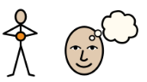
YOUNG PERSON VIEWS
(can be bullet points/drawings/photos/written sentence)
Name of child/young person:
Date:
Completed By:

(If not written in the first person, explains how views sought - Who obtained the views of the young person and/or parents/carers? How were they obtained – was it by a face-to-face meeting with a teacher/TA/LA officer? Telephone? Form? A meeting?)
Insert Picture/Drawing here
(this could be of you or what you love most)
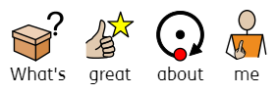 | 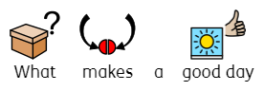
- Funny  - Kind  - Good listener  - Art | When I have a good nights sleep, had a good breakfast and understand what is being taught in class. My friends being nice, and kind and teachers have listened to me when I have asked for help.
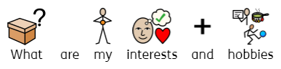 | 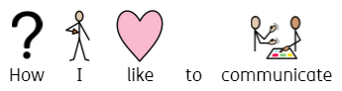
- Riding a bike  - Playing outside  - Lego  - Art | I use spoken language but visuals do support me with my communcation and understanding.
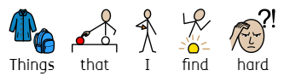 | 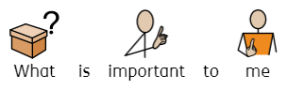
- When people shout around me  - When people use sarcasm  - When people touch my things without asking | - Science  - Family  - To be independent  - To drive  - Have a family  - Have a good job
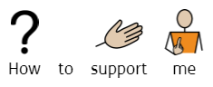 | 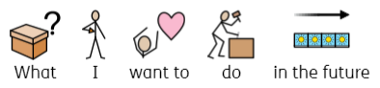
- Be kind and patient  - Know my signs when I am unhappy  - Ask if I need a brain break  - Visual support  - Remind and assist with my medication | I want to be a marine biologist when I am an adult.  I want to have a family and my own home.

Guidance/Prompt Questions:

What nice things people say about you, what do you think you are good at? What do you find easy?
What makes you have a good day?
What makes you happy? What makes you sad?

What type of job you want to have? Do you want live in your own place? Do you want to be able to drive? Have your own car? Do you want to be in a relationship? Do you want to have children?
What subject or lessons are your favourite at school or for young people, what college course, apprenticeship or qualifications you want?
Which people are most important to you? What other things are you interested in?

How you prefer to communicate? (e.g. talking to people or using sign or symbols) What help might you need to make decisions? How you like to learn? (e.g. reading about things or doing more practical things yourself) How you like to get more information? What kind of support works best for you?

