

Working with Parents in Conflict

How do I support parents?

# What the evidence tells us

Conflict between parents is normal, but if exposure is frequent, intense and poorly resolved, this can have a damaging impact on children, resulting in

long-term mental health issues and emotional, social, behavioural and academic problems as they grow up.

However, you can use these tools to work with parents by enhancing their relationship.

# Our framework for working with parents

Step 3: **supporting** constructive conflict communication

Step 2: **exploring** the causes of conflict

Step 1: **identifying** parental conflict

Vulnerability Stress Adaptation

In brief, the Vulnerability Stress Adaptation model helps us to understand the impact of stressful life events in the context of individuals’ past histories and the methods they use to adapt in these circumstances:

* **Enduring vulnerabilities** – Personal traits and past experiences that each person brings to the relationship.
* **Stressful events** – The life events they encounter, such as having a baby, illness and unemployment, increase partners’ need for support at the same time as reducing their capacity to provide it.
* **Adaptive processes** – How the couple communicate, behave, and cope during difficult times.

# Enhancing inter-parental relationships to improve child outcomes

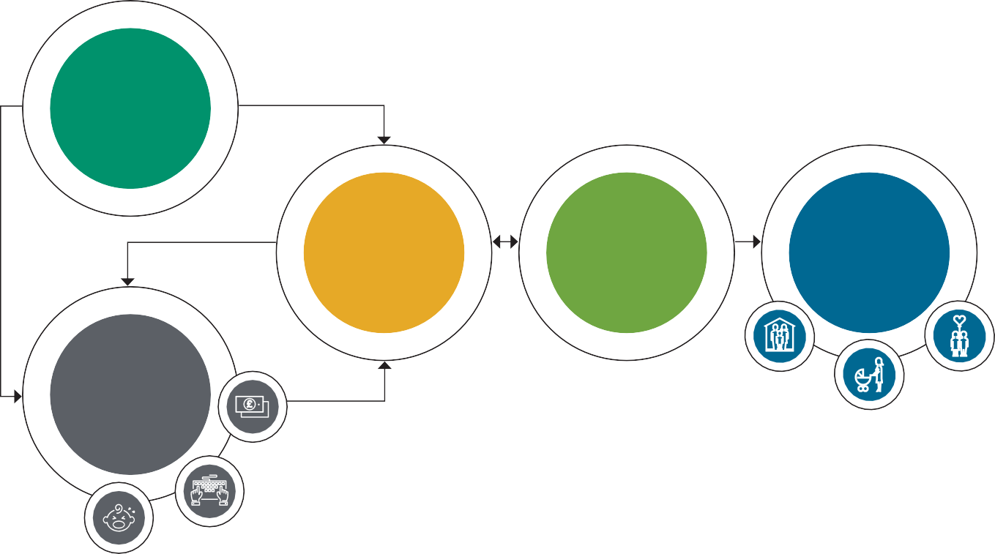

Each partner is likely to have enduring vulnerabilities which influence how they cope with one another and with stressful events.

**Enduring Vulnerabilities**

The stuff we bring with us

**Adaptive Processes** How we communicate

Relationship quality

Impact on family

outcomes

**Stressful Events** Stressful stuff happens

The quality of the interparental relationship is recognised as a primary influence on effective parenting practices and children’s long-term mental health and future life chances.

Children of all ages can be affected by destructive interparental conflict, with effects evidenced across infancy, childhood, adolescence and adulthood.

The context of the wider family environment is an important factor that can protect or exacerbate child outcomes in response to exposure to interparental conflict.

To work effectively with couples/co-parents we should:

* Use active, empathetic listening
* Use open questions
* Use probing prompts
* Reflect our understanding
* Summarise what we have heard

# Tools for working with parents in conflict

The following list shows the tools you reviewed as part of your training plus a couple of extras that we feel are useful.

You’ll also have tools in your everyday kit that you can use to work with parents.

The tools themselves are provided on the following pages for you to photocopy and use with parents.

## Stage 1 – Identifying parental conflict

* **Relationship scaling tool (page 5)** –

Use this to explore how each parent rates their situation on the scale from happy to distressed. This can highlight differences in how they are experiencing their relationship.

* **Stages of relationships (page 6)** – This model shows how relationships evolve over time. It helps to ‘normalise’ the difficult phases and reminds them that things can get better. It is often during the transition between these stages that conflict occurs.

## Stage 2 – Exploring the causes of the conflict

* **What’s going on for us? (VSA – page 7)** – Using the VSA model helps parents understand the connection between stressful life events, the parents’ past histories, and the methods they use to cope with stress or conflict, by asking them to reflect on these questions.
* **Thoughts, Feelings, Behaviour (page 8)** – This model can be used to help couples to recognise how they internalise behaviour that they observe which in turn affects how they feel, impacting on their response. This can be used to help couples understand each other’s behaviour.
* **Our typical day (page 9)** – Use this table to identify how the family see their typical day. You can use this during discussions with the parents or you can ask each parent to complete and bring

one to the next session. Once completed, ask them to consider when conflict is more likely to happen and what triggers it. Use this information to discuss what they could change to address and better manage conflict.

## Stage 3 – Supporting constructive conflict communication

* **Constructive or destructive prompt cards (page 10-12) –** These cards give some examples of constructive and destructive behaviours within conflict and can be used with families in a variety of ways to help them explore what is going on for them now and help them plot a path to take in

the future.

You may not feel that all the cards are suitable

for the family that you are working with, in that case, take some out and if the cards do not cover some of the issues you have identified in a family – consider creating your own (there are blank cards provided). Use the grid provided to explore how often these behaviours are demonstrated.

* **Role Cards (page 14)** – Ask parents to review these cards and give examples of situations they might get into and consider the role they are asking the child/ren to take on.
* **You vs. I statements (page 15-18)** – Use these cards to help parents to describe how they feel in a constructive way by using ‘I’ statements instead of ‘You’ statements to prevent conflict.

# Relationship Scales

**How are we doing?**

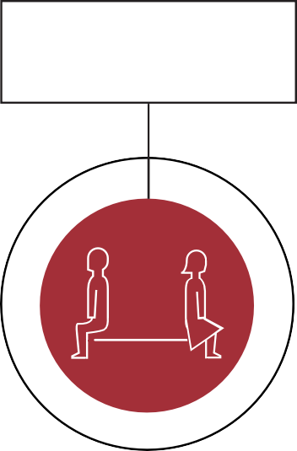

**Distressed**

**Happy**

# Stages of relationships



**Relationships develop over time**

Respect and Understanding 6



Finding Yourself 4

Acceptance 5

Power Struggle 3

Reality 2

Romance 1

# What’s going on for us

**Vulnerability Stress Adaptation Model**

How we communicate and resolve conflict

The stuff we bring with us

Enduring Vulnerabilities

Adaptive processes



Stressful

Stressful stuff happens

events

# Thoughts, Feelings, Behaviour

I see...



I behave...

Behaviour Observed

I think...

Behaviour Thoughts

Feelings

I feel...

# Our typical day

**What my day looks like Triggers to conflict**

Morning

Afternoon

Evening

Night

# Constructive or destructive

Using examples from the past to prove you’re right

These cards give some examples of constructive and destructive behaviours within conflict.

Asking each other’s point of view

Interrupting to get your point of view across

Recognising that whilst you may not agree, your partner has a valid point

Listening to the other point of view without interrupting

Withdrawing from the conversation as it’s

not going your way

Considering issues from somebody else’s point of view

Pointing out your partner’s flaws when

they support your argument

Raising your voice to make sure you get your point of view across

Allow each other the opportunity to express your views

Choosing the right time

Explaining how the situation is making you feel

Tell your partner what they should do

Using insults to make your point and share your feelings

Offering possible solutions to problems but be willing to compromise and listen to other suggestions

Come up with lots of possible solutions

Having a solution in mind to the problem and don’t change your mind

Check out what you agree about

Accepting that you might disagree

Show you understand the other person’s point of view

Ending an argument both feeling that you have been heard

Explaining why you feel the way you do

Ending an argument upset and angry

# In our relationship we...

Always

Sometimes

Never

Role Cards

Review these cards and give examples of situations you and your partner might get into and consider the role you are asking your child/ren to take on.

**THE MEDIATOR**

When your child feels they have to be the mediator between

parents, keeping everyone happy and solving problems

**THE JUDGE**

When you criticise

your partner or ex and expect your child to decide who

is right and wrong

**THE CONFIDANT**

When you share too much information with your child and expect them to fill the gap due to lack of intimate communication with your partner or ex

**THE SPY**

When you ask your child questions about your partner or ex and rely on them to find out what is going on

**THE MESSENGER**

When you ask your child to take information between you and your partner about

money, contact etc

# You and I statements

Use these cards to help parents to describe how they feel using ‘I’ statements instead of ‘You’ statements.

You never pay me any attention, you just don’t find me attractive

You care more about work than your own family

You’re always on the phone texting, on Facebook.

You care more about someone else’s opinion than mine

You leave me to do all

the tough parenting, so the kids like you more than me

You contradict me all the time when I am speaking to the kids

You don’t care about me and ignore me, you never call

or text me when you’re out

You’re always late and you are so unreliable

You don’t help out enough, you just expect me to clean up after you

You’re not interested

in anything I do any more

You’re more interested in what’s going on in

Eastenders than our lives

Something I am not sure about is……

Today I enjoyed……

I need help with……

I relax when……

I have support from……

I get irritated by……

I can help when……

I feel anxious when……

I struggle to……

Things go wrong when……

I enjoy when……

I would like us to start……

I would like us to stop……

I don’t understand why……

I would like us to keep……

I need help with……

Today I struggled with……

It would be great if……