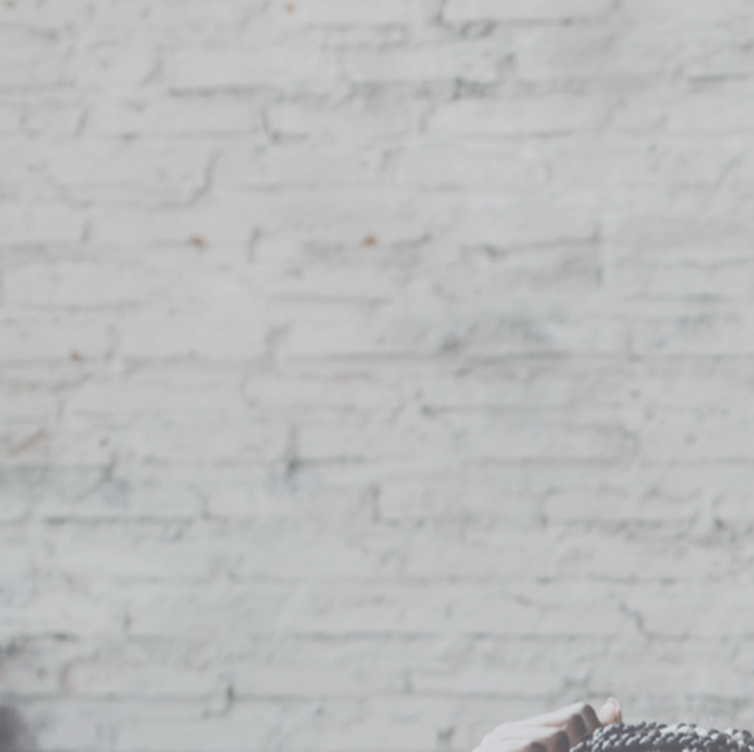

**Recognising and Supporting Parents in Parental Conﬂict**

Applying knowledge, skills and techniques

# Introduction

Conflict between parents happens, it is a normal process that occurs in all relationships. However, if the conflict is frequent, intense and destructive, this can have a damaging impact on a child.

Where you see signs of parental conflict, you have a responsibility to act through ‘early involvement’ with the aim of preventing the conflict escalating.

Key to effective support is:

* Being empathetic to the views and opinions of both parents
* Asking open questions to help understand the situation (e.g. How are things at home?)
* Listening to their responses

Your focus should be more on listening to help you build an accurate picture of the possible conflict that may be happening in their relationship.

What are some of the issues that can lead to signs of a distressed relationship? Record some of your thoughts below:

These are some of the issues that can lead to signs of a distressed relationship:

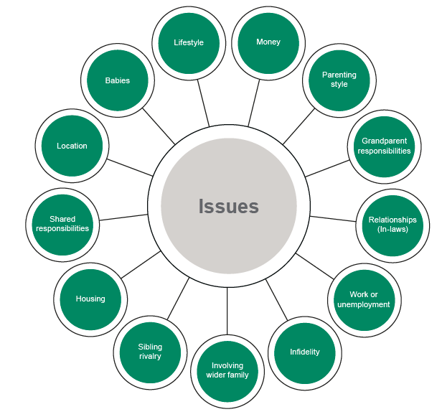

Parents may disclose some of these issues to you in conversations, this should act as a trigger for you to try and identify if these issues are causing a conflict situation in their relationship.

**These are some of the signs of a distressed relationship:**

Change in appearance

Anxiety and depression

Unexpected behaviours

Isolation and lack of empathy

# The Bradbury & Karney (2012) Vulnerability Stress Adaptation Model

The Vulnerability Stress Adaptation (VSA) Model can help you to understand the impact of stressful life events in the context of individuals’ past histories and the methods they use to adapt in these circumstances.

Everyone is different, and their capacity to deal with stressful events can vary considerably and, in some situations, can affect their relationship and this can have an impact on their children.

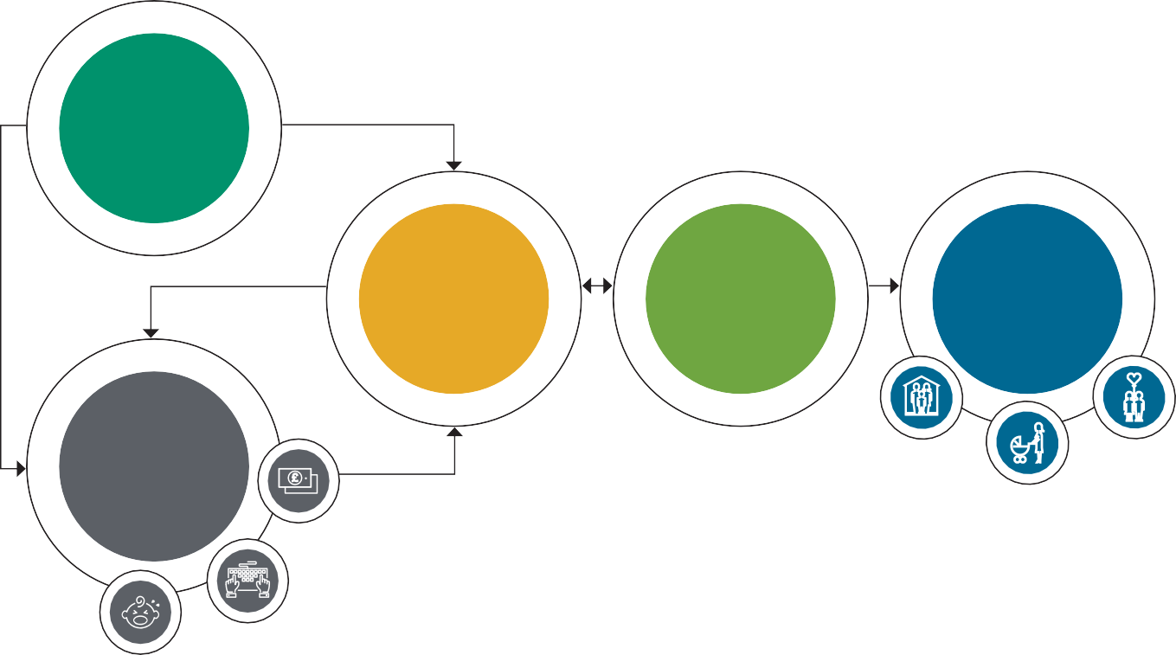

**Enduring Vulnerabilities**

The stuff we bring with us

**Adaptive Processes** How we communicate

Relationship quality

Impact on family

outcomes

**Stressful Events** Stressful stuff happens

* The stuff we bring with us – these are personal traits and past experiences that each person brings to the relationship (some people may not readily disclose this information)
* Stressful stuff happens – these can be things like having a child, becoming unemployed, illness or bereavement
* How we communicate – how the parents communicate, behave and cope during stressful events

A co-parenting couple with relatively poor coping and communication skills may remain happy in the relationship if they do not have to cope with many stressful events.

# Spotting Destructive Behaviours used by Parents in Distressed Relationships

The ‘Four Horsemen of the Apocalypse’ model below is used by Dr Gottman to show examples of behaviours that can result in relationship breakdown.



|  |  |
| --- | --- |
| Stonewalling | |
|  |  |
| Withdrawing to avoid conflict and convey disapproval, distance and separation. | |

Spotting examples like this when speaking with parents can help you to highlight their behaviours which may exacerbate their conflict.



|  |  |
| --- | --- |
| Defensiveness | |
|  |  |
| Victimising yourself to ward off a perceived attack and reverse the blame. | |

|  |  |
| --- | --- |
| Criticism | |
|  |  |
| Verbally attacking personality or character. | |

|  |  |
| --- | --- |
| Contempt | |
|  |  |
| Attacking sense of self with an intent to assault or abuse. | |

# Applying the Vulnerability Stress Adaptation (VSA) Model

Use the template below to make a record of information that you obtain when speaking with parents in a conflict situation.

This will help you to build a more detailed picture of what the parents are going through and will enable you to ask more relevant, focused questions during meetings/encounters with them to offer the right support to address their conflict.

The stuff we bring with us



How we communicate and resolve conflict

Enduring Vulnerabilities

Adaptive processes

Stressful events

Stressful stuff happens

# The Framework for Working with Parents in Conflict

Step 3: **supporting** constructive conflict communication

Step 2: **exploring** the causes of conflict

Step 1: **identifying** parental conflict

As you will be aware, this model underpins every aspect of your approach to dealing with parental conflict. The steps in the model help you to constructively resolve parental conflict.

Reflect on what you have learnt and record some thoughts on what you think your responsibilities are in each of the three steps. **Take action - think ‘what’s the most I can do?’**

* Step 1 – Identifying Parental Conflict (think about Dr Gottman’s 4 Horsemen model)
* Step 2 – Exploring the causes of the conflict (think about the VSA Model)
* Step 3 – Supporting constructive conflict communication (think about empathy and effective questioning)

# Things to consider when exploring parental conflict

* Remember that empathy is very important
* Listening actively to the parent’s responses
* How do we start the conversation?
* What is the right environment?
* What will your opening question be?
* How can we be fair to a parent who is not in the room? How can we avoid taking sides?
* How can we ask for more detail or clarification? How will that feel to parents? Can you explain why you need to know more?
* Can you sum up what you have heard and what it makes you think?
* Can you do this in a way that shows you’ve listened to their struggle and are not judging them?
* How can we persuade people that using support can be very helpful?
* How do we get real agreement for our next steps or plan?

Remember – if you are ever concerned that there is a risk of harm or abuse to anyone involved in the conflict situation you must follow your local Safeguarding procedures.

**Notes**

## Further information and guidance



The EIF Reducing Parental Conflict Hub provides a central resource for evidence and tools which may be of use.

Go to: https://reducingparentalconflict.eif.org.uk/

[www.clickrelationships.org](http://www.clickrelationships.org/) [www.dad.info](http://www.dad.info/) [www.netmums.com](http://www.netmums.com/) [www.relate.org.uk](http://www.relate.org.uk/) [www.contact.org.uk](http://www.contact.org.uk/)

https://[www.youtube.com/channel/UChghzqgbSSFI9hgbEUsKi2g](http://www.youtube.com/channel/UChghzqgbSSFI9hgbEUsKi2g)

   